Timeline:

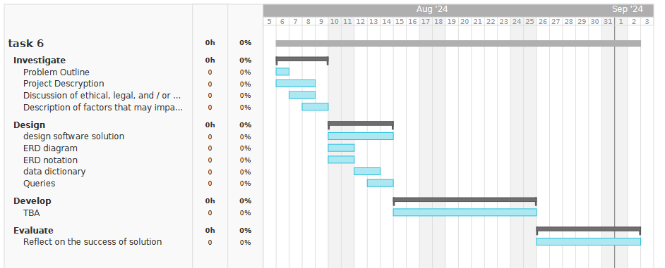

Problem Outline:

The problem outline is we need to create a music or video streaming service where users can somehow spend money for our products or services. This means we need a way to record all the music we have, the user’s information and their bank information, and all the purchases made on the platform.

Problem Description:

There will be scenarios where the user wants to view all the available music and buy the music with their money. The owner of the website will have scenarios where they will want to view today’s profits, overall profit, list of the number of each song sold, add music, remove music, and edit music.

The scenario where the user would want to view all the music available, we want to:

* Sort by alphabetical order, cost, length
* Show all music in a certain category such as genre, artist.
* In the database we will need an order, cost, duration, genre, and artist attribute for these features.
* In python we need a Get_Song_Records() function, Get_Songs_Records_By_Category(attribute, condition) for getting songs by category, Sort_Records(attribute, descending (bool) ) for sorting the records.

The scenario where the user will buy the music, we want to:

* Get the users bank details if we don’t have it yet
* Check if the bank details are valid
* Create a receipt with details such as user, cost, song, and other details.
* add bought music to user’s library so they can download it.

The scenario where the owner will want to view profits:

* Create functions to list overall, yesterday’s, last week’s, last month’s, and last year’s profit.
* Create functions to show profit of a certain year.
* Show how much money a certain song or genre made.

The scenario where the owner will add and remove songs:

* Have a simple interface that’s makes it easy to add, remove, and modify music.
* Check if added or modified music follows domain integrity.

Ethical, legal, and/or security issues:

Because we’ll be storing personal data, once we start making 3 million dollars profit, we will need to follow the Australia Privacy Act. We must be open about how we manage personal information. We must give users the ability to be anonymous or allowed to use a pseudonym. Only collect sensitive information when necessary. We must outline what personal information we need and why we need it. We can’t sell the information. The information must have currency, authenticity, relevance, and accuracy.

If we collect user bank details, unless allowed by the user, we will have to delete the data (but the details will still be on the receipt just in case we need to review it at a later date).

For security, data will be encrypted, the server storing the data will not be allowed to send data outside a network only to the front-end server.

References:

<https://soundcharts.com/blog/music-metadata>

<https://i.imgur.com/qvMJzsP.jpeg>